Call Center 2018 Declines

There has been softness in consumer calls to our DTC Call Center team after visiting our website. There was a small Year over Year (YOY) decline in January 2018 vs January 2017 but we’ve seen a steady downward trend in both YOY call change and Month over Month (MOM) call change throughout the year. The DTC team would like to know whether this is due to macro trends (Someone less likely to call to buy a mattress in 2018, national advertising, etc) or if it could be due to something more micro (type of traffic coming to the website, something changed on site that would decrease calls).

**For Dan Fines Team: Does this need to be a predictive model or just a view of the relationship between features for this snapshot in time?**

Project Sponsors: Dan Fine, Brody Rodgers, Eric Mueller

Data Analyst: Rich Wolff

Project Start: 2018-06-25

Last Update: 2018-06-25

# Initial Questions to Explore

* Are consumers more driven to shopping (different from buying) on online channels vs on the phone in 2018?
* Is this systemic decline or does it come from a certain few markets?
* Does call center volume have a relationship with various marketing channels?
* Are there certain events on the website that share a relationship with volume of call center data?
* Are consumers heading to competitive websites after visiting Tempurpedic.com and does this reduce calls?
* Does source of traffic correlate with # of phone calls (do direct/organic search users call more?)

# Data sources to be used

|  |  |
| --- | --- |
| * Incontact Call Center Calls   + Initial calls   + User 2nd calls ( > 1 day later )   + Calls by area code * Marketing Data   + Online ad spend by website/medium (Video, carousel, shopping, brand, direct)   + Offline ad spend by channel   + Retailer advertising metrics * Hitwise Competitive Website Data   + Upstream/downstream from tempurpedic * Time series   + Daily (activities are closer to the time of phone calls, relationships will be tightest)   + Weekly   + Monthly | * GA Website Data   + Sessions   + Pageviews per session   + Session Duration   + Mattress Unique Page views   + Pillow Unique Page views   + Retail locator unique page views   + Add to cart events   + Cart views   + Size changes on product pages   + Unique Users in in 2017 vs 2018   + Source of visits (Organic Search/Direct vs paid sources) * ZS Survey data   + Online vs offline shopping preferences   + Consumer journey steps and change over time |

# Nice to Have Data If Existed

* User data that connects website visits to phone call (classification algorithms to solve)
* Dates different features on website goes live. Do we track dates features change on website?
* Mattress Distribution/Retailer distribution (Tempur showrooms by month, TSID/TSIO showrooms by month)
* Outcome of DTC phone call (did they buy?)

# Initial Data Exploration

We’ll be going through three steps during this data exploration. They include:

1. Identifying the ideal call center metric
2. Exploring how that metric has changed over time
3. Measuring changes in various features that may affect our call center metric and how the two relate.

## Identifying the Ideal Call Center Metric

Some initial questions arise at this phase:

* Have all channels of phone calls decreased?
* Is the decrease in first time callers, repeat callers (2nd call is at least 24 hours from initial call), or in all callers?
* What is the largest source of call center phone calls?

When we speak of channels in the call center, we are referring to the group of phone numbers that identify where the consumer called from. Looking at only DTC Sales focused calls, we see that 88% of calls initiate from our website, transfers to the DTC team, or from paid search efforts.

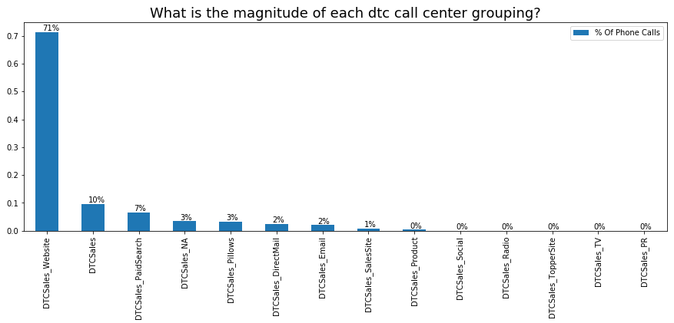

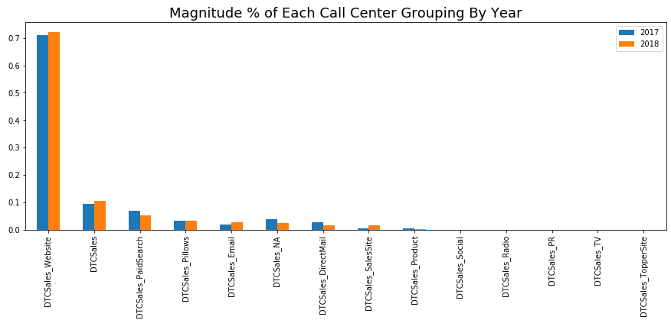

Call Grouping By Year

If we were to look at this by year, we don’t seem much change from 2017 to 2018. In fact, when we looked at this % daily, the trends hold steady every day, throughout two years.

After speaking with the head of the DTC call center, I’ve determined that DTCSales_Website and DTCSales_PaidSearch aggregated will be closest to real consumer behavior. By mirroring what we believe is closest to actual consumer behavior, we’ll be able to align what consumers do as we change different features of our call center campaign.

Moving forward, call center calls will refer to the sum of DTCSales_Website and DTCSales_PaidSearch.

## How Have Call Center DTC Sales Daily Calls Changed Over Time?

Looking at year over year call center volume by week, we see fairly comparable volume from weeks 1 – 9 while there is a stark decrease of volume starting in week 10 (right of the red line in the graphic below). The change is so deep that in the first 9 weeks, the worst YOY change we observed was a decrease of 284 calls. After week 10, the smallest decrease we observed was 315 calls.

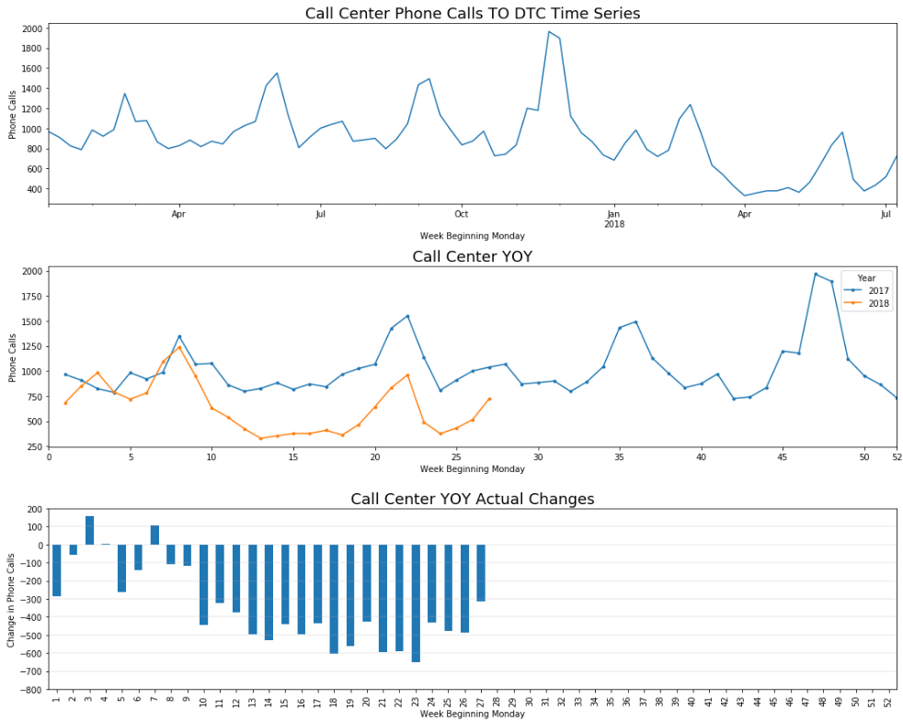

At this point, we know there is a difference in call volume from week 10 on. To know if we need to look prior to week 10 for something that may have cause this shift, we’ll perform a statistical test for year over year change weeks 1-9.

**Hypothesis:** There is no difference between call center volumes in 2018 vs 2017 through weeks 1 - 9 at a 95% confidence interval.

**Null Hypothesis:** There is a decrease in call center volumes in 2018 vs 2017 through weeks 1 - 9 at a 95% confidence interval.

**Statistic:** Difference of means (2018 average weekly volume less 2017 average weekly volume)

**Test:** Permutation Test

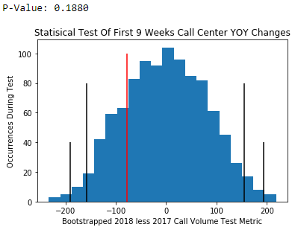

95%

95%

99%

99%

Observed

**From our P-Value of .1880 we accept the hypothesis that call center volumes have not changed 2018 vs 2017 YOY through weeks 1-9% at 95% confidence intervals.**

**Although we did observe an average weekly change of 78 calls it’s well within the range we’d expect. In fact, we should expect weekly changes anywhere between down 191 calls per week to up 193 calls per week.**

**How does this compare to week 10 and on? During week 10+ we saw an average decrease of 484 calls per week. This is 6.2 times the average decline of weeks 1-9.**

**As I begin to look for information that may explain call center volume changes, I’ll focus my efforts primarily on the sudden change that happened during week 10. Secondarily, we’ll focus on the trend of being slightly down (weeks 1-9). Our initial thoughts of the week’s 1-9 decline may be brand related and we can focus on Brand Tracker metrics to see if these align with the call center decline.**

## Independent Variables That May Have an Effect on Call Center Volume

**Because of the sudden change in volume in week 10, I don’t believe we have a consumer behavior issue. We would see a slower decline over time as consumers, as a whole, won’t stop calling a call center all at once.**

**N12 Preferred Mattress Shopping Channel**

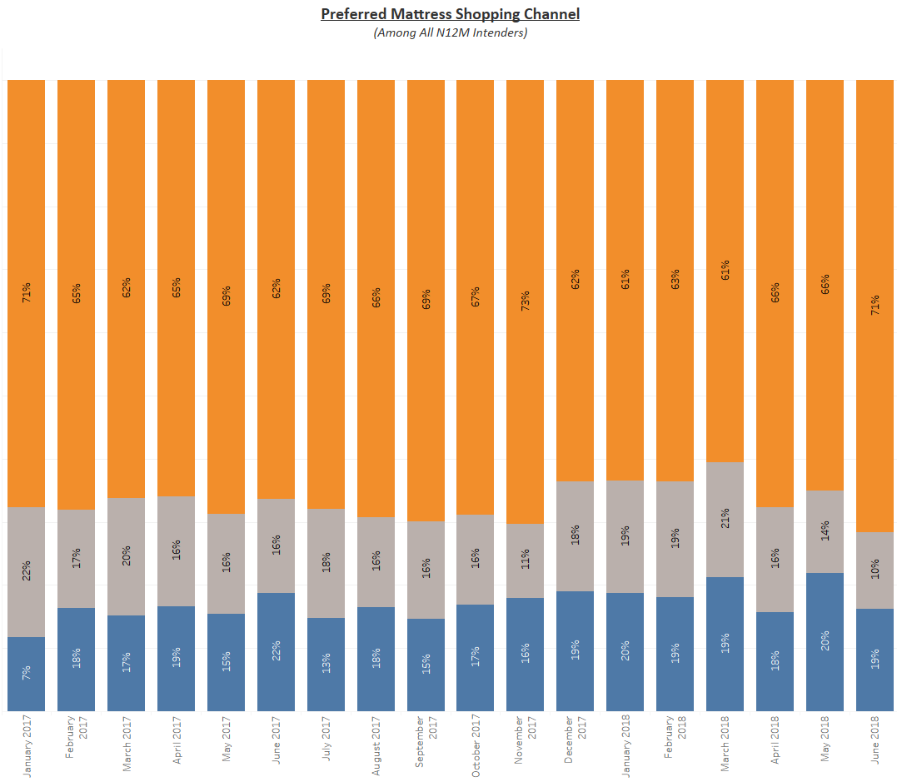

Although we don’t have specific questions in our brand tracker concerning buying or shopping for a matress over the phone, we do have data about buying online / in person. The trends over time have not shifted away from either channel which leads me to believe we wouldn’t see a sudden shift in preference to shop through our call center either.

Circled in red is March 2018.

**Next, the goal is to identify what may have caused the sudden shift in calls during week 10. This is also week beginning March 5th 2018 and ending March 11th 2018. We’ll first look to any changes we may have made to the website that would have cause a sudden shift in calls coming from our website.**

After digging through website changes records from our manager that oversees the development of our website, we found TSI changed our phone number on the website from a vanity number (844-6-TEMPUR) back to a standard phone number (888-811-5053). After asking about this change, we also uncovered we changed options a consumer would hear after dialing into our Interactive Voice Response system. The verbiage a consumer heard changed from “For sales press 1” to "To place a new order for a Tempur-Pedic Product please press one." This change happened on 3/13/2018 or week 11.

Here is a chart highlighting call center volume along with the different changes made surrounding the call center.

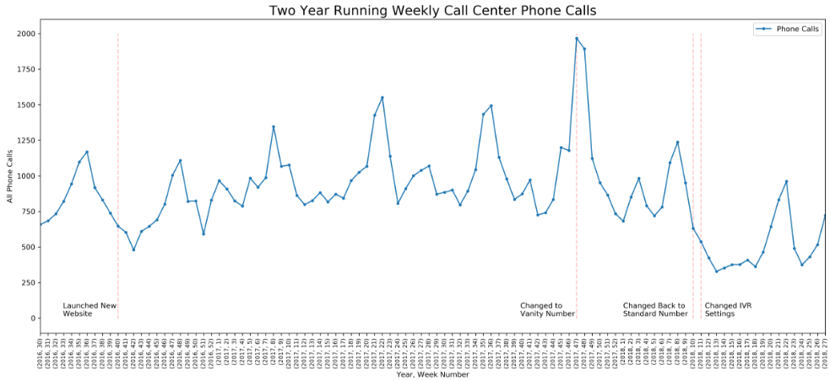

During week 47, we changed our standard phone number to the vanity number. Although we saw a large jump in call volume, this is probably due to a very good black friday/cyber Monday in 2018. The weeks that follow we see normal trends. Since there was no significant upward trend after changing to a vanity number, I would not expect a significant decrease going back to the standard number. At this point, we can rule out the vanity number change to standard number as a source of call declines.

More interesting to me is the IVR settings change. This more closely aligns with the sudden decrease in call volume and may be the change that caused our decrease in calls.

As a side note, we do see a trend of increasing call center volume starting when we launched our new website in 2018. When I break this out by 1st time callers (identified by phone number) and repeat callers (a phone number called a second time at least 24h after their initial call) we do not see an increasing trend among first time callers. The increase can be seen coming from repeat callers.

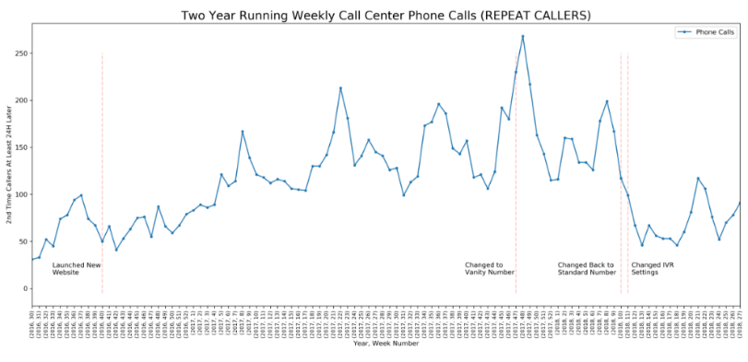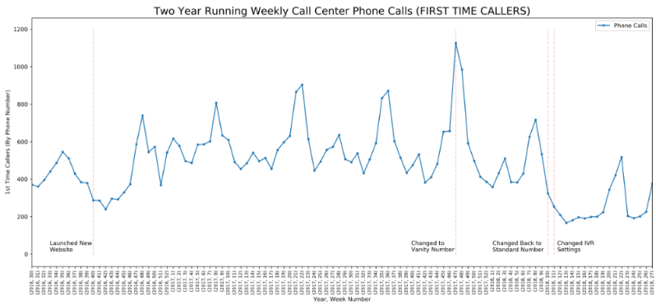

This suggests we are not growing the number of new callers (in fact we see a slight downward trend starting in q3/q4 of 2017) which has held steady until we changed the IVR settings.

We’re not sure what this means yet but it may be of interest for future deep dives.

So far, my initial hypothesis include:

* Changing the IVR has led to a dramatic decrease in calls to our DTC team.
* We may have a brand issue that is leading to slow decline of calls over time.

Moving on, we’d like to look at the different sources of digital advertising and how they may relate to call center volume. The top two features that correlate with call center volume include ad channels Google branded search impressions and Bing branded search impressions (as defined by TSI’s director of performance marketing).

First up is Google Branded Search Impressions.

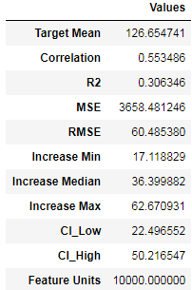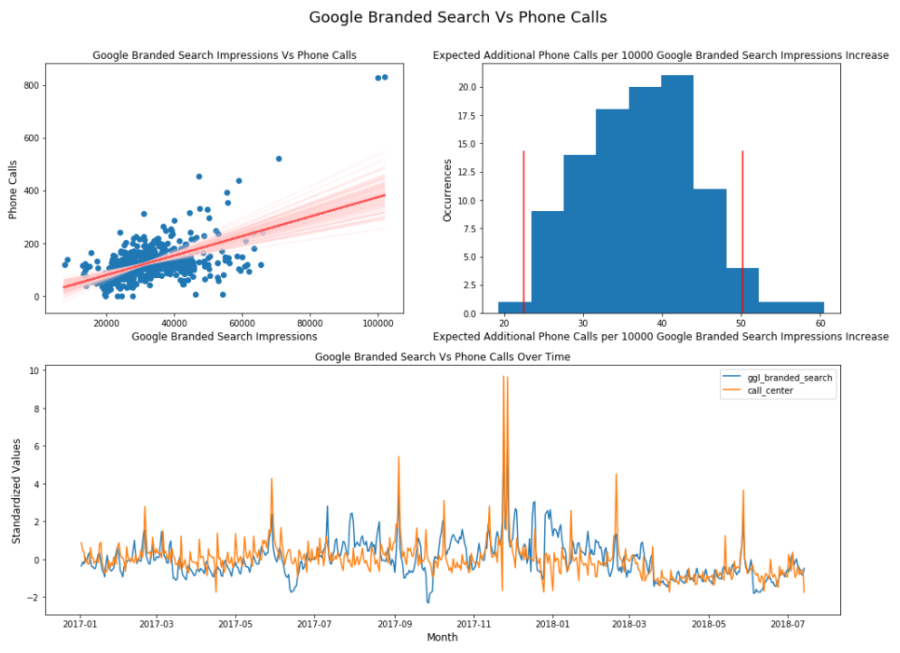

The relationship between phone calls and our Google Branded Search impressions is a moderate one. We see a correlation of .55. For every 10,000 impressions of Google Branded Search, we can expect an increase between 23 and 50 calls. When we fit a line to the scatterplot (top left chart) the line generally will predict the mean daily phone calls of 126 +/- 60 calls (anywhere from 60 – 180 calls).

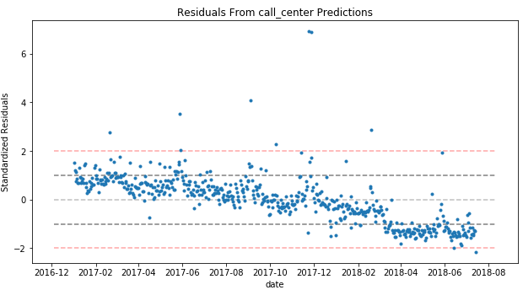While this tells us there is a relationship here, there is a lot of missing information while predicting calls. We can use a residuals plot (actual values less predicted values) to find where this variable comes up short.

What we see in the residuals is impressions of google branded search do not pick up on the longer term downward trend in call center volume. It also doesn’t pick up on the sudden change in volume that happened in March 2018. Finally, there are quite a few points above the +1 and +2 standardized value line that is not predicted. This is probably due to holiday weekends.

We do see a tight band of residuals, even in the downward trend, which suggests google branded search impressions has some relationship with call center volume.

Next, we’ll look at bing branded search impressions. We should expect much of the same.

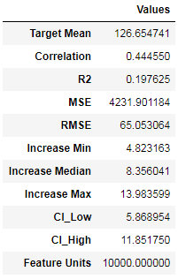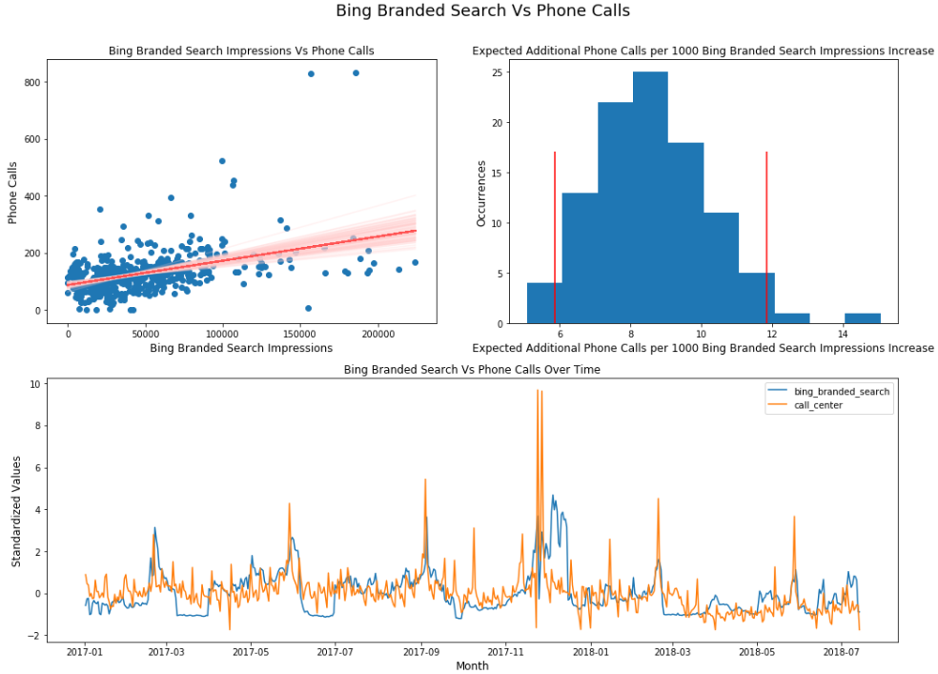

The relationship between phone calls and our Bing Branded Search impressions is a moderate one but less than google’s. We see a correlation of .44. For every 10,000 impressions of Bing Branded Search, we can expect an increase between 9 and 12 calls. When we fit a line to the scatterplot (top left chart) the line generally will predict the mean daily phone calls of 126 +/- 65 calls (anywhere from 55 – 185 calls).

Again, we see a little bit of a relationship here but the residuals will tell us a lot more.

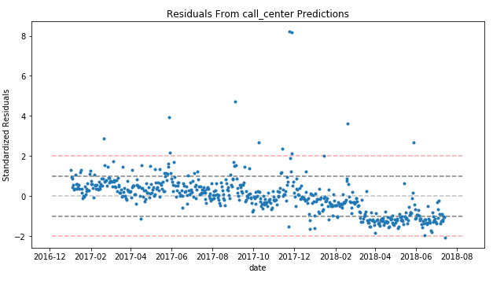We see much of the same trends in the residuals from the bing prediction as we did in the google prediction. This doesn’t add a whole lot of new info.

I also performed the same test with Google and Bing impressions combined with much of the same results.

My takeaway here is that it’s important to get those who search our brand to our website so they can then research our beds and order/call our DTC team if they need more info. These consumers should be prioritized as they have raised their hands as having interest in our brand.

Next, we want to see if the source of traffic matters to our call center volume.

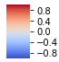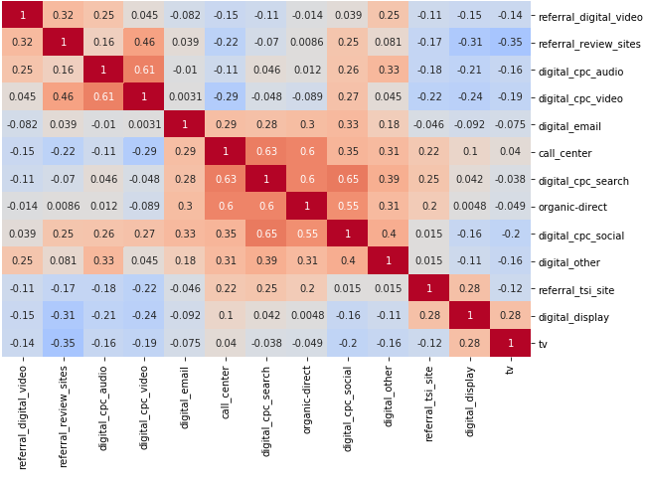

**Correlation Heat map of Google Analytics Traffic Sources with Call Center Volume**

Correlation

When looking at correlations of website traffic sources to call center volume, CPC search sources (bing, google, yahoo, etc) rise to the top with a moderate correlation of .63. Organic Search/Direct visits come in second at .60. After that the next closest is CPC social at .35, which signifies almost no relationship.

Because we already looked at various CPC search sources, we’ll focus in on organic searc/direct visits.

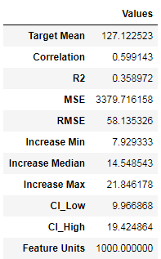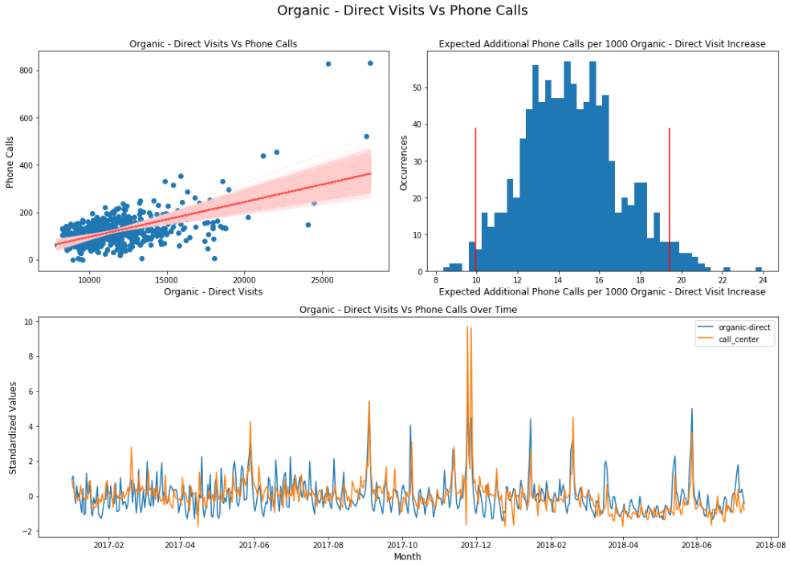

The relationship between phone calls and our Bing Branded Search impressions is a moderate one but less than google’s. We see a correlation of .44. For every 10,000 impressions of Bing Branded Search, we can expect an increase between 9 and 12 calls. When we fit a line to the scatterplot (top left chart) the line generally will predict the mean daily phone calls of 126 +/- 65 calls (anywhere from 55 – 185 calls).

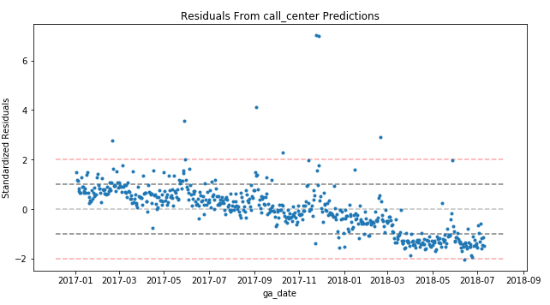Again, we see a little bit of a relationship here but the residuals will tell us a lot more.

We see much of the same trends in the residuals as from our CPC tests.

My initial belief is that the trend of consumers reaching our website no matter if they come through CPC channels or through direct/organic search has some effect on DTC sales calls. The changes in visits from cpc and direct/organic search does not capture a longer term downward trend of phone calls and certainly doesn’t catch the sudden drop in March 2018.

Finally, we’ll look at brand tracker to see we can predict this slow downward trend over time.

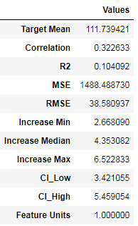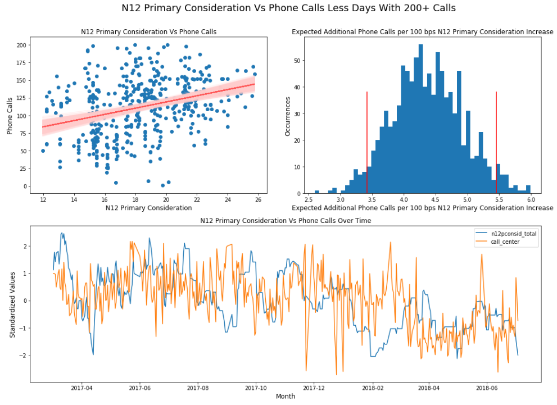

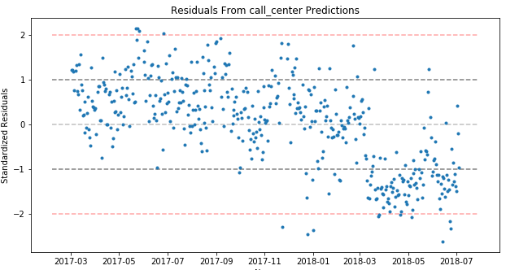When looking at our brand metrics, we use a rolling 14 day primary consideration of next 12 month intenders. Because this is a longer term metric (we wouldn’t want to look at this daily) we cannot expect for it to catch much of the day to day movement. What we do see is a slight correlation (because of the day to day volatility) and generally as we increase our N12 primary consideration, we see phone calls increase. The more interesting metric will be the residuals.

In our residuals, the downward trend is mostly accounted for. This may mean the slight downward trend of our call center metric may mirror that of our slight downard trend in our brand metrics. Note we see a lot of error which is expected due to the volitility of our brand metric.

This still does not capture the sudden drop in March 2018. Again, I believe we’ll account for that when the IVR change is layered in.

Finally, before we move into the modeling, I’d like to visualize the relationship between primary unaided awareness (top of mind) and our call center metrics.

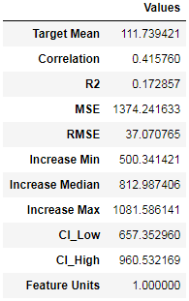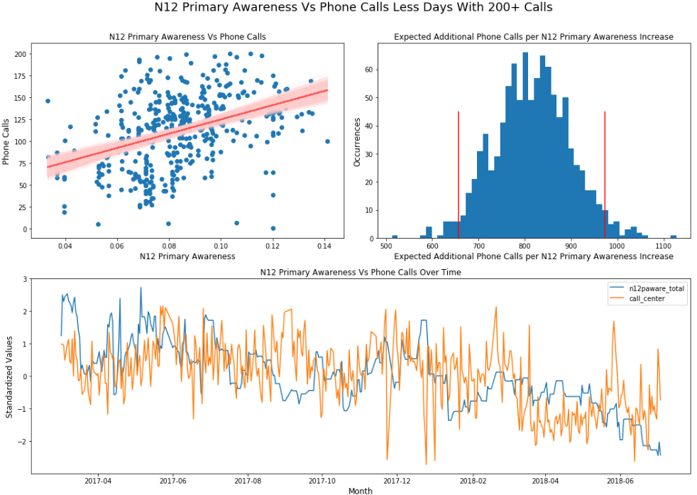

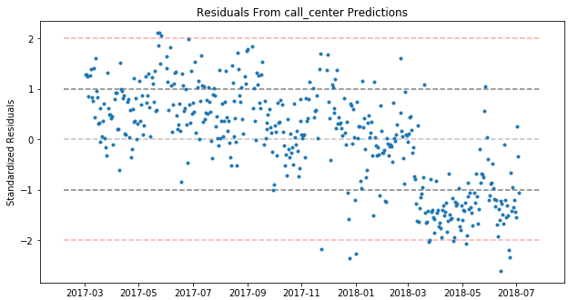We see a higher correlation using a rolling 14 day primary awareness (top of mind unaided awareness) of next 12 month intenders than we do of N12 primary considerers. This could be because if a brand is top of mind, a consumer may be more likely to search for it first.

Again, because this is a longer term metric (we wouldn’t want to look at this daily) we cannot expect for it to catch much of the day to day movement.

In our residuals, we see mostly the same trends as in our N12 Primary Considerers. The longer term downward trend is mostly accounted for. Note we see a lot of error which is expected due to the volitility of our brand metric.

Again, this still does not capture the sudden drop in March 2018.

In the next section, we’ll bring this all together in a linear regression model.

# Modeling the Behavior of Call Center Volume Using Multivariate Regression

There will be two steps to this analysis.

1. Review of the requirements and steps of modeling
2. Explain our findings

**Requirements**

* Include a feature to capture IVR system change
* Include categorical features to capture national promotions, holday Monday’s, non shopping holidays (think christmas) where call volume is 0 or very very low
* Include impressions of digital cpc branded search split by google and bing
* Include impressions digital cpc google shopping and google mattress categorized campaigns
* Include 14 day rolling average N12 Primary Consideration
* Include 14 day rolling average N12 Primary Unaided Awareness (top of mind)

**Steps**

* Split the data into a training and test set of data; Save the test set as a “holdout” data set
* Build the model on training set of data
* Cross validate the model across 5 folds of the training set to ensure goodness of fit
* Test the model accuracy by running the unseen data through the trained model and capture the score

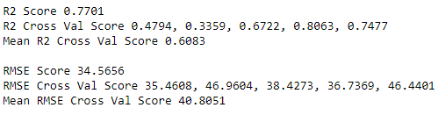

Our first iteration of the model scored very well. We had a fairly high R2 score of .77 that had a generally good cross validation with a mean cross validation score of .60. Generally speaking, we want the cross validation mean score to be as close to the R2 score as possible.

The RMSE score was had a generally good fit as well. With a daily mean of 120 calls, the model will predict within 85 and 155 calls.

Let’s look at the predicted vs actuals line chart.

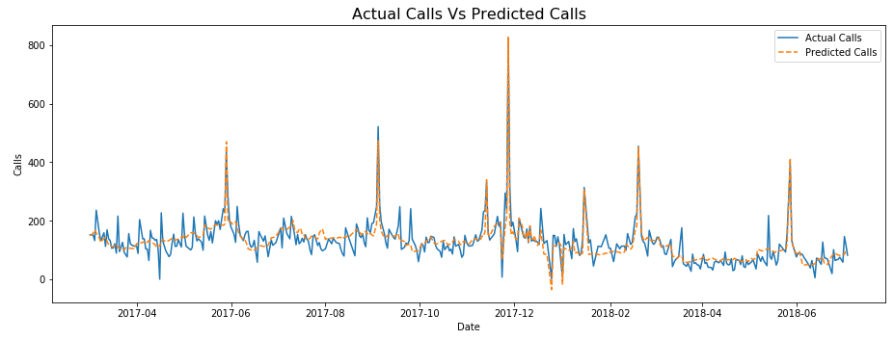

First thing that jumps out is that the predicted line generally moves in line with what we observe from the actual calls. It does seem to miss the daily seasonality. We’ll add that in for our next iteration. Also Black Friday in 2017 performed extremely well and way beyond any other period seen. I added in a feature for that day to help the model generalize around other features better.

For the next iteration in modeling, I added in features that account for seasonal swings of a week by adding Monday to Sunday as features. This results in a higher scoring model and a better generally fitted model.

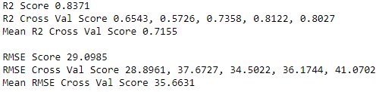This time, we see a R2 score of .83 with a cross validation score of .71. The RMSE score was had a generally good fit as well. With a daily mean of 120 calls, the model will predict within 91 and 149 calls.

Visuallizing the predicted line vs the actual line, we a much better fit.

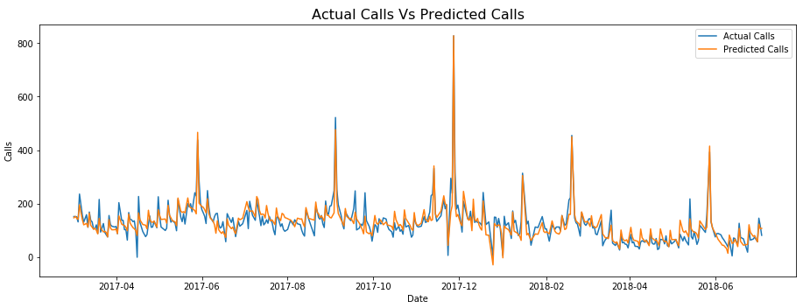

Next, when we look at the residuals, much of the trend problems and sudden decline in march problems seem to fade away.

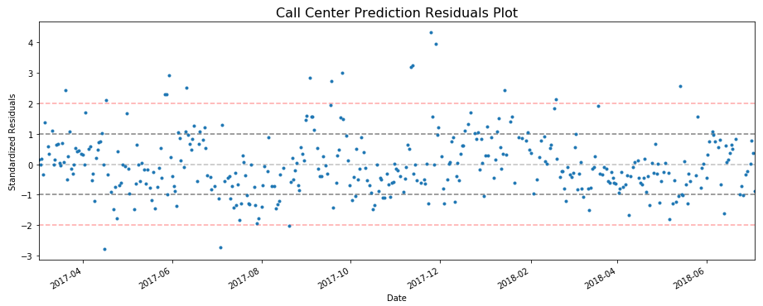

I have three initial thoughts:

1. We capture the slow downward trend seen over 2017
2. We capture the sudden decline in march 2018
3. The data still does not seem to be random which may mean we’re missing features. It almost looks like a sine wave exists in the residuals (Seasonality? Is competition stealing our potentail consumers? Does this follow low offline media periods?)

Before we look at what may be driving the model, let’s see how it performs on unseen data to ensure we are not overfitting the model.

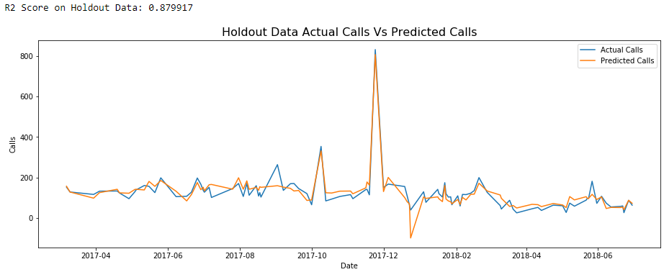

The model has a R2 score of .88 on unseen data which is even better performance than what it was trained on. This confirms that although we are missing some data that explains some shifts in calls, our model is a good, predicitve model overall. It captures the gradual decline of calls and captures the sudden shift down in March.

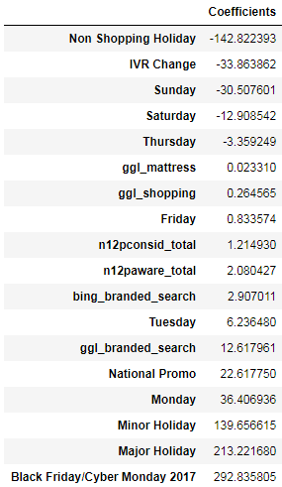First off, outside of the call center being closed, the IVR change is largest detractor of call volume. This means the day we changed the IVR settings, we saw a drop of about 34 calls per day, on top of other downard trends.

Next we see the biggest gains in calls come from the day of a holiday (labor day itself, memorial day itself, etc). There’s a difference between the major holidays, such as presidents day and memorial day vs minor holidays such as martin luther king day and veterans day. Also, we see an inrease of 23 calls per day when there is a national promotion.

As we look at dtc advertising, we see the following results:

* For every 10,000 impressions of Google branded search, we receive 13 additional calls
* For every 10,000 impressions of Bing branded search, we receive 3 additional calls
* For every 10,000 impressions of google shopping we’ll receive .26 calls (or 3 calls for every 100,000 impressions)
* For every 10,000 impressions of google mattress, we receive .02 calls.

Finally, let’s visualize the range the features may affect call center calls.

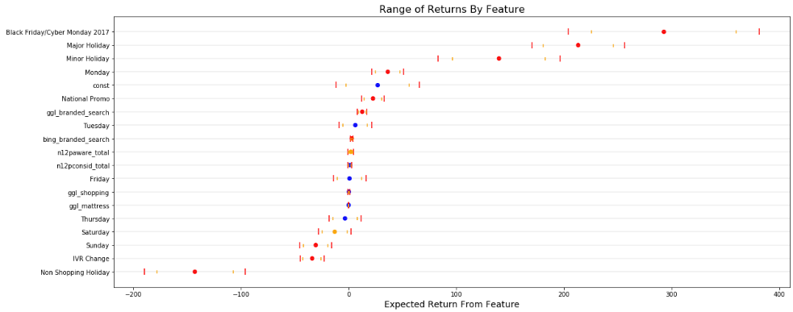

There’s a lot of data in here, some that we can not control. I’ll filter out holidays, the constant, days of week, and non shopping holidays to leave us with brand metrics, national promotions, the top 4 digital marketing channels, and the IVR change.

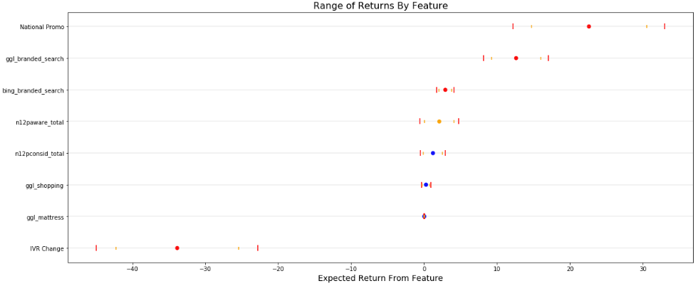

As we read through this, the colored circle is the coefficient from the model while the color stands the P-Value. The color red stands for a P-Value of .01 or less, orange stands for a P-Value of .05 to .01, and blue is greater than .05. The markers symbolized by | sprawling left to right are the range of values we should expect.

Walking through each output:

* Being on a national promotion is most likely worth 23 calls per day but can range from 12 to 33 additional calls.
* Google search impressions are most likely worth 13 calls per 10,000 impressions. This can range from 8 to 17 calls per 10,000 impressions.
* Bing search impressions are most likely worth 3 calls per 10,000 impressions. This can range from 2 to 4 calls per 10,000 impressions.
* N12 Primary Awareness (Top 1 unaided awareness) is most likely worth 2 calls per 100bps. This can range from 0 calls to 5 calls. Note, this is not as significant to the model as our digital ad spend and national promotion.
* N12 Primary Consideration, Google Shopping Impressions, and Google Mattress impressions are not significant and represent very little call volume.
* IVR Change is most likely worth -34 calls per day and can range anywhere from -45 calls to -23 calls.

# Summary

Our original problem arose from a small YOY decline in January 2018 vs January 2017 and a steady downward trend in both YOY call change and MOM call change throughout the year. We were able to identify that while call volume was down the first 9 weeks of the year, it was well within the expected range of call variation given prior weeks of call data. We were able to note that there was a significant drop in call center volume starting week 10. We were also able to identify a slow downward trend is call center starting q3/q4 2017.

In the case of the sudden drop in calls starting week 10, the data points to the cause being a change to TSI’s Interactive Voice Response system. This is worth a decline of about 34 calls per day and could be between a decline of 23 and 45 per day. Weekly, this is a decline of between 161 – 315 calls.

In the case of the slower downward trend, the data points to a declining rolling 14 day N12 Primary Awareness or unaided top of mind awareness. We’ve seen our N12 primary awareness fall from 10% down to 7% in the latest quarter. The data points to 100bps of N12 primary awareness most likely being worth 2 calls. In a week this is worth 14 calls or 60 calls in a month. The model ranges from 100bps being worth 0 calls to 5 calls. There may be some opportunity here to refine with a more robust timing. Is rolling 14 day correct? Should it be rolling 21 or 28 day?

Finally, in the case of digital advertising, the data points to branded search impressions are the most import ad spend we can do. Intuitively, this makes sense. If a consumer is searching our brands, there is probably some level of consideration for our products. Google search impressions are most likely worth 13 calls per 10,000 impressions. This can range from 8 to 17 calls per 10,000 impressions. Bing search impressions are most likely worth 3 calls per 10,000 impressions. This can range from 2 to 4 calls per 10,000 impressions. Since consumers that search our brand are most likely to call, we should continue to focus here and ensure we drive them to our website. A possible leading indicator we may want to explore is a ratio of website visits to total brand searches.

# Potential To-Do / Follow Ups

Finally, some potential to dos and follow ups. We’ll split this up by the DTC/Call Center team and Analytics team.

## DTC/Call Center Team To-Dos

* Update verbiage on IVR.
  + We changed from “For sales press 1” to "To place a new order for a Tempur-Pedic Product please press one." Try changing this back to see if there’s an impact.
  + BEST OPTION: Perform an A/B test. Serve half of our website visitor one phone number with one IVR message and the other half of our website visitors another phone number with another IVR message. This will provide the highest knowledge gain for better decision making.
* Continue with Branded Search Marketing.

## Analytics Potential To-Dos

* Break phone call data out into area code and map to Nielsen DMA markets for a more granular market analysis to answer the original question, “Is this systemic decline or does it come from a certain few markets?”
* Clean weekly traditional media data layer into this analysis. Part of this will be to find the time decay of our advertising.
* Work with DTC to identify website events that happen and may lead to a phone call.
* Work in hitwise downstream and hitwise share of visits data to layer in how competition affects phone calls.
* Identify what is behind the “sine” wave in the model’s residuals.
* Find and apply the optimal length of time for brand tracker metrics that we should be using (14 day, 28 day?)
* Set up statistical test’s alongside of the DTC and Call Center team to measure effects of the IVR change.